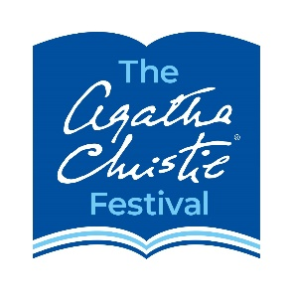
The Agatha Christie Festival Mystery Short-Story Writing Competition 2023
ENTRY FORM

NAME: First Name, Second Name

EMAIL ADDRESS (where we can contact you)

NATIONALITY

POSTCODE WHERE YOU LIVE IN DEVON – OR POSTCODE OF YOUR SCHOOL/COLLEGE IN DEVON

TITLE OF YOUR STORY

AGE (as at 12 AUGUST 2022)

IF YOU ARE UNDER 16 YEARS OF AGE, PLEASE ASK YOUR PARENT, GUARDIAN or TEACHER to check this BOX to confirm that they have read & agreed the Terms & Condition of your entering this competition | [ ] Yes, I confirm I have read and agree to the terms and conditions of the competition.  ADULT’s NAME & EMAIL ADDRESS:  -----------------------------------------------------------
IF YOU ARE 16 YEARS OF AGE OR OVER, PLEASE check this BOX to confirm you have read and agreed the Terms & Conditions of your entering this competition | [ ] Yes, I confirm I am 16 years of age or over and have read and agree to the terms and conditions of entering this competition

This personal data will be used or the purpose of administering the prize and in accordance with Agatha Christie Festival Ltd’s privacy policy, Agatha Christie Festival Ltd will use the contact details provided to send general updates about the competition by email. Your personal data, including your contact details will not be used for any other purpose(s).

PLEASE EMAIL THIS FORM, TOGETHER WITH YOUR STORY, TO info@iacf-uk.org

CLOSING DATE FOR ENTRIES : 11 AUGUST 2023

