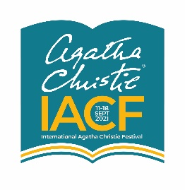 21 December 2021
FOR IMMEDIATE RELEASE
Daniel Schumann appointed International Agatha Christie Festival Director
The Trustees of the International Agatha Christie Festival are pleased to announce that Daniel Schumann will take up the post of Festival Director with effect from January 2022. Daniel is a senior producer, manager and fundraiser in the arts and theatre industry with more than 15 years’ experience working across a diverse range of organisations both in the regions and the West End. His most recent position is as Lead Producer at The Almeida Theatre in London. His is the founder of Viva Arts & Community Group, an arts charity benefitting children and young people. He is an elected member on the Arts Council Regional Board for the South East.
Chair of Trustees, Heather Norman-Soderlind, said: ‘We are delighted to welcome Daniel to the role of Festival Director at a time of increased interest in the growth and future of the Festival across Torbay and the English Riviera.’
Daniel Schumann said: ‘I am thrilled to be joining the Festival at this exciting time and look forward to continuing and building upon the excellent work that the Festival has done to date.’

About Agatha Christie Festival Limited
Agatha Christie Festival Limited, a registered charity, uses the global reach of Torquay-born Agatha Christie’s reputation to promote local and international engagement in literature and the arts, supporting the cultural ecology of South West England and delivering value to the visitor economy of our region.

Working in partnership with cultural venues, community-based charities and civic organisations, we stage the International Agatha Christie Festival annually across one week in September to celebrate Christie’s life and legacy and use Festival receipts and other funding, including from Arts Council England, to deliver a programme of literary arts projects across the year for identified disadvantaged communities in Torbay (Torquay, Brixham, Paignton) which counts among the 20% most deprived areas in England. The 2022 Festival will run from 10th -17th September across the English Riviera. For more information contact chair@iacf-uk.org
www.iacf-uk.org
@AgathaFestival

